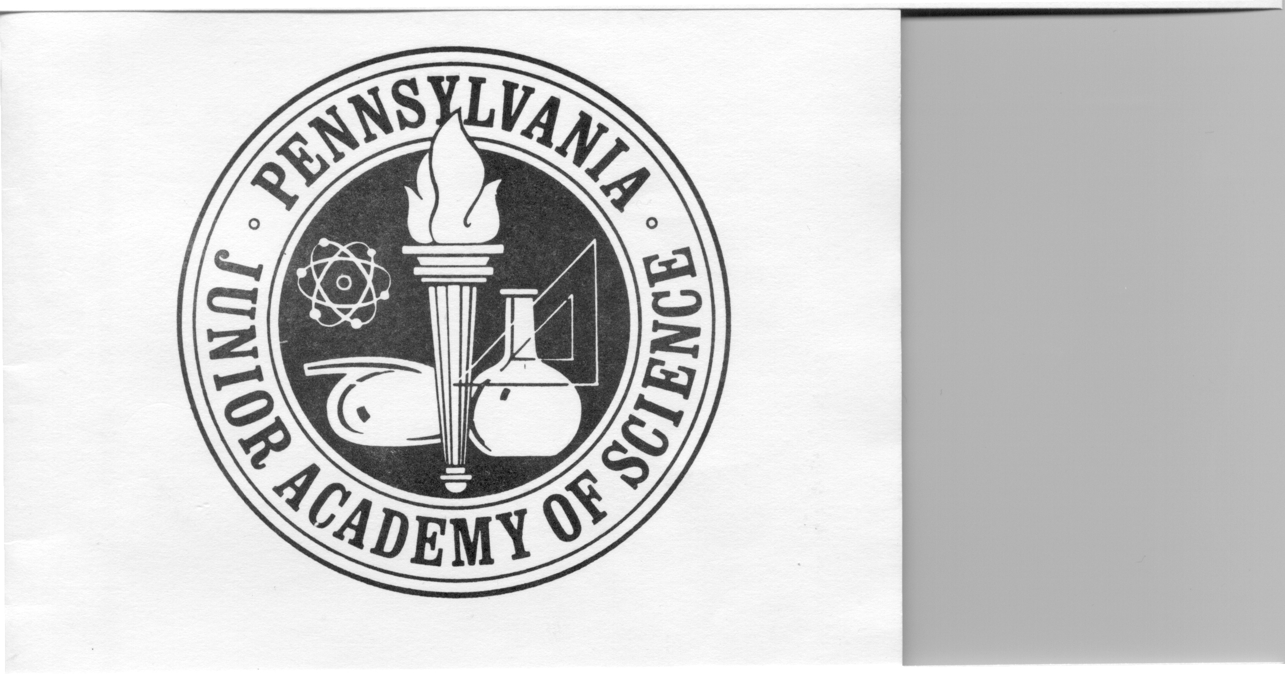
Pennsylvania Junior Academy of Science
Region 1B
School/Affiliation Registration Form
Registration is $50.00 per school.
Please make a check out to PJAS Region 1B.

Please print out this form and mail with check to address below by October 31st, 2024. Checks should be made out to PJAS Region 1B. Schools in the same district can combine checks and pay in one lump sum, please just indicate below. Don’t forget to also register electronically as well. Register here electronically.

Mail to: Russ Wolff
PJAS Region 1B/Treasurer
Cheltenham High School
500 Rices Mill Road
Wyncote, PA 19095

Please Print/type!

- School/Affiliation: _________________________________________________

- Lead Sponsor: _________________________________________________

- Address _________________________________________________________

_________________________________________________________

4. Phone(C): _______________________________

5. E-mail: ___________________________

Alternate E-mail: __________________________________

